## PROGRAM DEFINITION

|  |
| --- |
|  |
| * A program to generate a report for a list of billing accounts per agreement number |

## RELATED TABLES

|  |  |
| --- | --- |
|  | **Access** |
| * - | * - |

## ROLES

|  |  |
| --- | --- |
|  | **Test** |
| * User that has access to program |  |

## INITIAL PROCESS

|  |  |
| --- | --- |
|  | **Test** |
| * Set VAR_COMPANY_ID = Login User’s Company ID * Set VAR_USER_ID = Login User ID * Set VAR_LANG_ID = Login User’s Language ID * Get Property List to Combobox Property [PROPERTY_LIST]:   EXEC RSP_GS_GET_PROPERTY_LIST ‘VAR_CCOMPANY_ID’, ‘VAR_LANGUAGE_ID’  Set Value : CPROPERTY_ID Set Display : CPROPERTY_NAME  As Parameter: CPROPERTY_ID   * Jalankan RSP_GS_GET_PERIOD_YEAR_RANGE dengan parameter, simpan hasil ke VAR_GSM_PERIOD   + VAR_COMPANY_ID   + ‘’ (Empty String)   + ‘’ (Empty String) |  |

## MAIN FORM

### USER INTERFACE

#### INITIAL VERSION

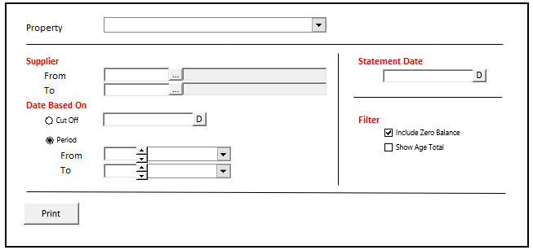

### BUTTON DEFINITION

|  |  |
| --- | --- |
| **Button Name** | **Action** |
| Print | Run PRINT REPORT PROCESS |

### DISPLAY PROCESS

#### FIELD DEFINITION

|  |  |  |  |
| --- | --- | --- | --- |
| **Name** | **Field** | **Type** | **Validation** |
| Property | Set Value : CPROPERTY_ID  Set Display : CPROPERTY_NAME  As Parameter: CPROPERTY_ID | Combo box | * Mandatory * Get DataSource from [PROPERTY_LIST] * IF Combobox Empty when hit Button Print:   Display message “Please select property !” |
| From Supplier | * CFROM_SUPPLIER_ID * CFROM_SUPPLIER_NAME   Value : CFROM_SUPPLIER_ID | Textbox & Button Lookup | * Supplier Name always disabled * Supplier Id & button lookup always enabled * Do Lookup APL00100 SUPPLIER LOOKUP, Parameter:   + VAR_COMPANY_ID   + Selected Property ID (CPROPERTY_ID)   + VAR_LANG_ID * Set CFROM_SUPPLIER_ID = lookup.CSUPPLIER_ID * Set CFROM_SUPPLIER_NAME = lookup.CSUPPLIER_NAME |
| To Supplier | * CTO_SUPPLIER_ID * CTO_SUPPLIER_NAME   Value : CTO_SUPPLIER_ID | Textbox & Button Lookup | * Supplier Name always disabled * Supplier Id & button lookup always enabled * Do Lookup APL00100 SUPPLIER LOOKUP, Parameter:   + VAR_COMPANY_ID   + Selected Property ID (CPROPERTY_ID)   + VAR_LANG_ID * Set CTO_SUPPLIER_ID = lookup.CSUPPLIER_ID * Set CTO_SUPPLIER_NAME = lookup.CSUPPLIER_NAME |
| Cut Off | * If Cut Off Radio isChecked Then   + Set CCUT_OFF_DATE = Selected Date   + Set CFROM_PERIOD = ‘’   + Set CTO_PERIOD = ‘’ | Radio button | * If Cut Off Radio isChecked Then   + Enabled Cutt Off DateTimePicker   + Disabled From Period   + Disabled To Period |
| Cut Off Date | Value : CCUT_OFF_DATE | Date picker | * Mandatory, if Enabled/Cut Off Radio Button isChecked   + IF Date Empty when hit Button Print:   Display message “Please select cut off date !”   * Set default value: SELECT dbo.RFN_GET_DB_TODAY (VAR_COMPANY_ID) |
| Period | * If Period Radio isChecked Then   + Set CCUT_OFF_DATE = ‘’   + Set CFROM_PERIOD = Selected CFROM_YEAR + CFROM_MONTH   + Set CTO_PERIOD = Selected CTO_YEAR + CTO_MONTH * Value : CFROM_PERIOD, CTO_PERIOD | Radio button | * If Period Radio isChecked Then   + Disabled Cutt Off DateTimePicker   + Enabled From Period   + Enabled To Period |
| From Period Year | Value : CFROM_YEAR | Spinner  Spinner value:   * Minimum = VAR_GSM_PERIOD.IMIN_YEAR * Maximum = VAR_GSM_PERIOD.IMAX_YEAR | * Mandatory, if Enabled/Period Radio Button isChecked   + IF Period Empty when hit Button Print:   Display message “Please select period !”   * Set default spinner value:   SELECT **YEAR**(dbo.RFN_GET_DB_TODAY (VAR_COMPANY_ID)) |
| From Period Month | Value : CFROM_MONTH | Combo box  Set VAR_PERIOD_MONTH_LIST (as array of object) with VAR_MONTH_NUMBER and VAR_MONTH_NAME.  Set VAR_MONTH_NUMBER = 01, 02, … , 12  Set VAR_MONTH_NAME = January, February, … , December | * Mandatory, if Enabled/Period Radio Button isChecked   + IF Period Empty when hit Button Print:   Display message “Please select period !”   * Set default combo box value month name based on   SELECT **MONTH**(dbo.RFN_GET_DB_TODAY (VAR_COMPANY_ID)) |
| To Period Year | Value : CTO_YEAR | Spinner  Spinner value:   * Minimum = VAR_GSM_PERIOD.IMIN_YEAR * Maximum = VAR_GSM_PERIOD.IMAX_YEAR | * Mandatory, if Enabled/Period Radio Button isChecked   + IF Period Empty when hit Button Print:   Display message “Please select period !”   * Set default spinner value:   SELECT **YEAR**(dbo.RFN_GET_DB_TODAY (VAR_COMPANY_ID)) |
| To Period Month | Value : CTO_MONTH | Combo box  Set VAR_PERIOD_MONTH_LIST (as array of object) with VAR_MONTH_NUMBER and VAR_MONTH_NAME.  Set VAR_MONTH_NUMBER = 01, 02, … , 12  Set VAR_MONTH_NAME = January, February, … , December | * Mandatory, if Enabled/Period Radio Button isChecked   + IF Period Empty when hit Button Print:   Display message “Please select period !”   * Set default combo box value month name based on   SELECT **MONTH**(dbo.RFN_GET_DB_TODAY (VAR_COMPANY_ID)) |
| Statement Date | Value : CSTATEMENT_DATE use for Header to Report | Date picker | * Mandatory * IF Period Empty when hit Button Print:   Display message “Please select period !”   * Set default value:   SELECT dbo.RFN_GET_DB_TODAY (VAR_COMPANY_ID) |
| Include Zero Balance | Value : LINCLUDE_ZERO_BALANCE | Check box  Set:   * When True, then 1 * When False, then 0 | * Optional * Set default value to False |
| Show Age Total | Value : LSHOW_AGE_TOTAL | Check box  Set:   * When True, then 1 * When False, then 0 | * Optional * Set default value to False |

### PRINT REPORT PROCESS

#### REPORT LAYOUT 1

PAPER SIZE: A4 PORTRAIT

FONT SIZE: 8

DATE BASE ON: **CUT OFF DATE**

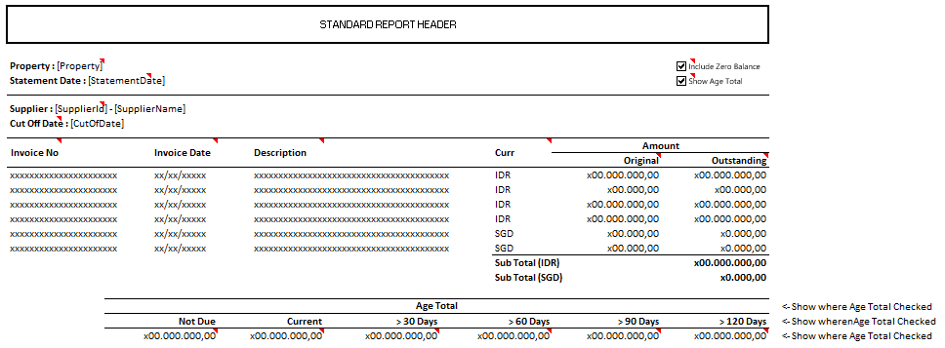

##### REPORT DEFINITION

|  |  |  |  |
| --- | --- | --- | --- |
| **Section** | **Name** | **Field** | **Validation** |
| HEADER 1 | Property | Selected Property | Show Property ID – Property Name  Ex. “ABCDE – Global Property” |
| Statement Date | Selected Statement Date | If there is no date standardization, then use format “dd Mon yyyy”  Ex. “14 Sep 2001”  Else, use date standardization |
| Cut Off Date | Selected Cut Off Date |  |
| Include Zero Balance | Selected Filter [Include Zero Balance] | If Filter [Include Zero Balance] = True, then show check box with checked value  Else, show check box with unchecked value |
| Show Age Total | Selected Filter [Show Age Total] | If Filter [Show Age Total] = True, then show check box with checked value  Else, show check box with unchecked value |
| REPORT GROUP | Supplier | CSUPPLIER_ID |  |
| Currency Code | CCURRENCY_CODE |  |
| GROUP BY Supplier [HEADER] | Supplier | CSUPPLIER_ID – CSUPPLIER_NAME | New Page on each Supplier |
| GROUP BY Currency [HEADER] | Currency Code |  | Suppress |
| DETAIL | Invoice No. | CREF_NO |  |
| Invoice Date | CREF_DATE | Display Date as standardization |
| Description | CTRANS_DESC |  |
| Curr. | CCURRENCY_CODE |  |
| Original | NORIGINAL_AMOUNT |  |
| Outstanding | NOUTSTANDING_AMOUNT |  |
| GROUP BY Currency [FOOTER] | Sub Total(Curr Code) |  | Sum of NOUTSTANDING_AMOUNT for each Currency |
| GROUP BY Supplier [FOOTER] | Not Due | NAGE_NOT_DUE_AMOUNT | If Filter [Show Age Total] = False, then Suppress this section  Else  Show this section |
| Current | NAGE_CURRENT_AMOUNT |
| > 30 Days | NAGE_MORE_THAN_30_DAYS_AMOUNT |
| > 60 Days | NAGE_MORE_THAN_60_DAYS_AMOUNT |
| > 90 Days | NAGE_MORE_THAN_90_DAYS_AMOUNT |
| > 120 Days | NAGE_MORE_THAN_120_DAYS_AMOUNT |
| Unallocated Payment | NAGE_UNALLOCATED_PAYMENT |
|  |  |  |  |

#### REPORT LAYOUT 2

PAPER SIZE: A4 PORTRAIT

FONT SIZE: 8

DATE BASE ON: **PERIOD**

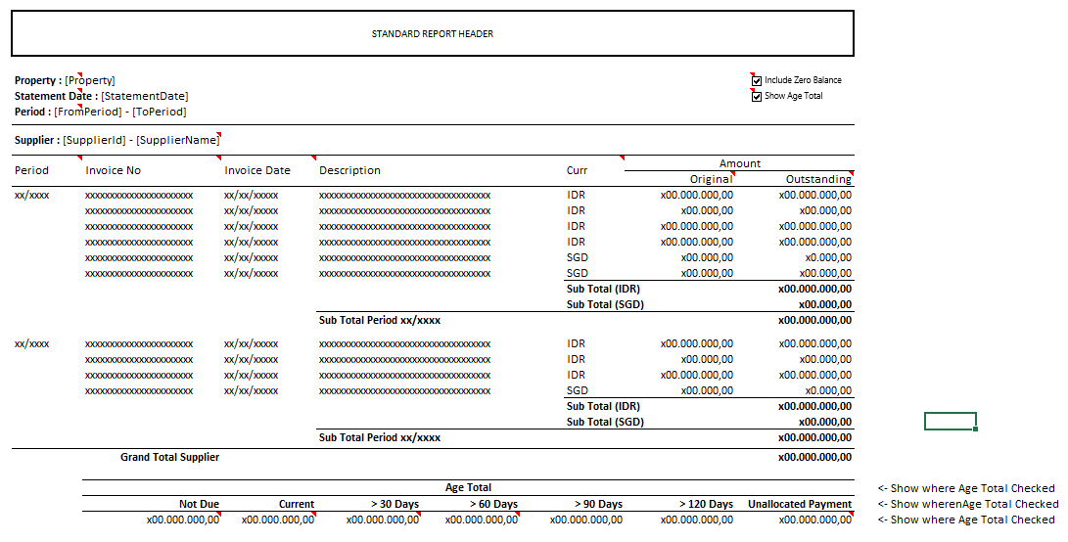

##### REPORT DEFINITION

|  |  |  |  |
| --- | --- | --- | --- |
| **Section** | **Name** | **Field** | **Validation** |
| HEADER 1 | Property | Selected Property | Show Property ID – Property Name  Ex. “ABCDE – Global Property” |
| Statement Date | Selected Statement Date | If there is no date standardization, then use format “dd Mon yyyy”  Ex. “14 Sep 2001”  Else, use date standardization |
| Period | Selected Period | Show From Period – To Period |
| Include Zero Balance | Selected Filter [Include Zero Balance] | If Filter [Include Zero Balance] = True, then show check box with checked value  Else, show check box with unchecked value |
| Show Age Total | Selected Filter [Show Age Total] | If Filter [Show Age Total] = True, then show check box with checked value  Else, show check box with unchecked value |
| REPORT GROUP | Supplier | CSUPPLIER_ID |  |
| Period | CREF_PRD |  |
| Currency Code | CCURRENCY_CODE |  |
| GROUP BY Supplier [HEADER] | Supplier | CSUPPLIER_ID – CSUPPLIER_NAME | New Page on each Supplier |
| GROUP BY Period [HEADER] | Period |  | Suppress |
| GROUP BY Currency [HEADER] | Currency Code |  | Suppress |
| DETAIL | Period | CREF_PRD | Suppress IF PREVIOUS CREF_PRD = CREF_PRD |
| Invoice No. | CREF_NO |  |
| Invoice Date | CREF_DATE | Display Date as standardization |
| Description | CTRANS_DESC |  |
| Curr. | CCURRENCY_CODE |  |
| Original | NORIGINAL_AMOUNT |  |
| Outstanding | NOUTSTANDING_AMOUNT |  |
| GROUP BY Currency [FOOTER] | Sub Total(Curr Code) |  | Sum of NOUTSTANDING_AMOUNT for each Currency |
| GROUP BY Period [FOOTER] | Sub Total (Period) |  | Sum of NOUTSTANDING_AMOUNT for each Period |
| GROUP BY Supplier [FOOTER 1] | Grand Total (Supplier) |  | Sum of NOUTSTANDING_AMOUNT for each Supplier |
| GROUP BY Supplier [FOOTER 2] | Not Due | NAGE_NOT_DUE_AMOUNT | If Filter [Show Age Total] = False, then Suppress this section  Else  Show this section |
| Current | NAGE_CURRENT_AMOUNT |
| > 30 Days | NAGE_MORE_THAN_30_DAYS_AMOUNT |
| > 60 Days | NAGE_MORE_THAN_60_DAYS_AMOUNT |
| > 90 Days | NAGE_MORE_THAN_90_DAYS_AMOUNT |
| > 120 Days | NAGE_MORE_THAN_120_DAYS_AMOUNT |
| Unallocated Payment | NAGE_UNALLOCATED_PAYMENT |
|  |  |  |  |

#### ACTION

|  |
| --- |
|  |
| * Execute this stored procedure:   RSP_APR00300_GET_REPORT  VAR_COMPANY_ID  , selected Property ID  , selected From Supplier Id  , selected To Supplier Id  , selected Cut Off Date  , selected Date Based On [Period [From]]  , selected Date Based On [Period [To]]  , selected Include Zero Balance  , selected Show Age Total  , VAR_LANGUAGE_ID |
|  |

# CR LIST

|  |  |  |
| --- | --- | --- |
| **CR** | **Description** | **Notes** |
|  |  |  |

#### TEMPLATE

#### VALIDATION

|  |  |  |
| --- | --- | --- |
| **Field** | **Condition** | **Validation Message** |
|  |  |  |
|  |  |  |

#### ACTION

|  |
| --- |
|  |
|  |